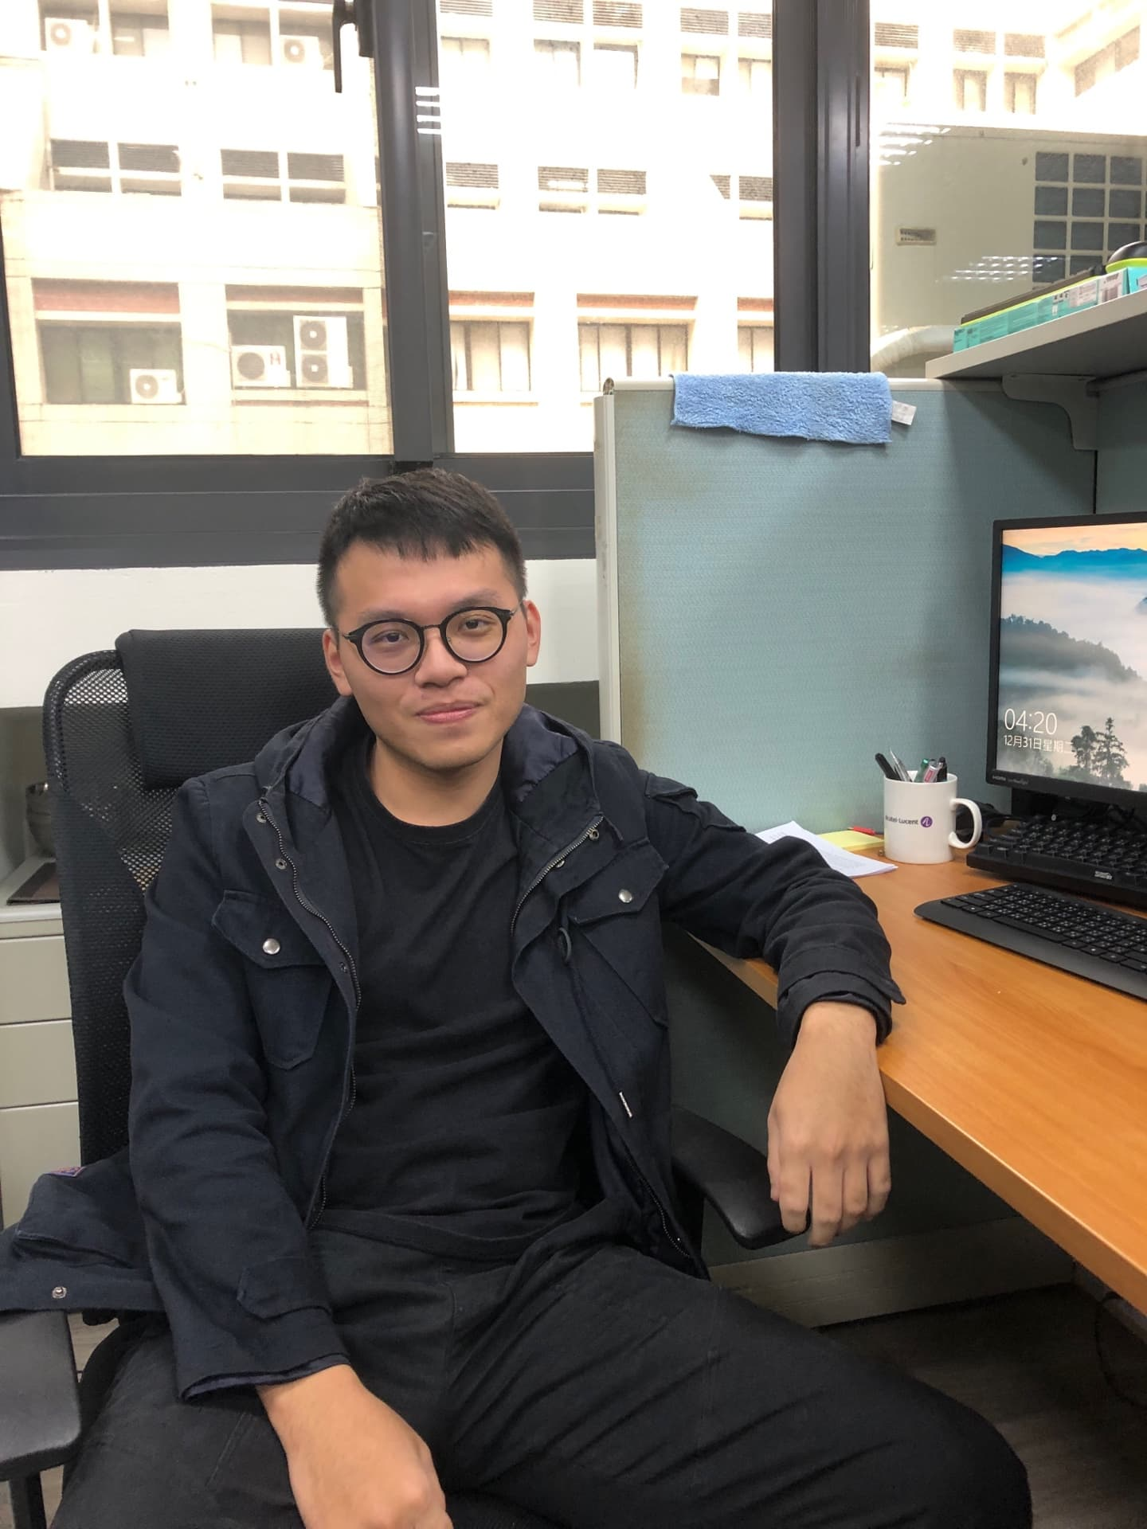

阮建元 JIAN-YUAN RUAN

Mail:kevinian320@gmail.com

Received Bachelor Degree in the Department of Computer Science and Engineering from National Taiwan Ocean University in Keelung ,Taiwan in 2018. His goals are to learn advanced techniques and refine his programming skills on practical project,implementation. His research interest in Software Defined Networking and Machine learning.